**Sets of numbers**

**1. Theme: Sprint Project 2020**

**2. Creators:**

Stoyan Mihaylov Ponchev Xg – SMPonchev18@codingburgas.bg - Scrum Trainer

Yavor Alexandrov Karakolev Xb – YAKarakolev18@codingburgas.bg - Back End Developer

Viktor Georgiev Kavaldzhiev Xv – VGKavaldzhiev18@codingburgas.bg - Front End Developer

Radoslav Milenov Ivanov Xg – RMIvanov18@codignburgas.bg - Checker

**3. Summary:**

**4.1 Project goals**

The main goal is to make a program that deals with actions connected with any type of sets.

* 1. **Main stages in the implementation of the project**
* ***I stage – Analise***
* ***II stage – Plan***
* ***III stage – Realization***
  1. **Level of difficulty**

The level of the difficulty of our project is not very high because the program is on a basic level of mathematical solutions. We only have three general functions with sets of elements. In the future we are going to add more functions and actions so we can improve the program for different type of mathematical tasks.

* 1. **Logical and functional description of the solution**

Description of the functions:

* SetChoice (Void function) – This function asks you to choose with which set of elements you want to work with. That function is only used in one of the other functions – Substract.
* EnterSetEl (Void function) – This function is used to input the size of the sets and type all the elements in the set with which you are going to work with.
* Intersec – (Void function) This function checks which numbers contain in both two sets of numbers and displays them on the screen. It displays only the numbers that are in both sets and concur.
* Subtract (Void function) – Function that display which numbers from the first set don’t contain in the second set and displays them on the screen. It also checks the opposite (if the second set don’t contain numbers that are in the first one).
* Union (Void function) – Function that displays all the numbers from both sets and if there are numbers that are both in the two sets and concur it display the given number/s only once.
* Hello (Void function) - This is a greeting function for all the users.
* Options (Void function) – Function that shows all the options our program can give to the user.
* Main (Int function) – The main function. Has only one row.
* 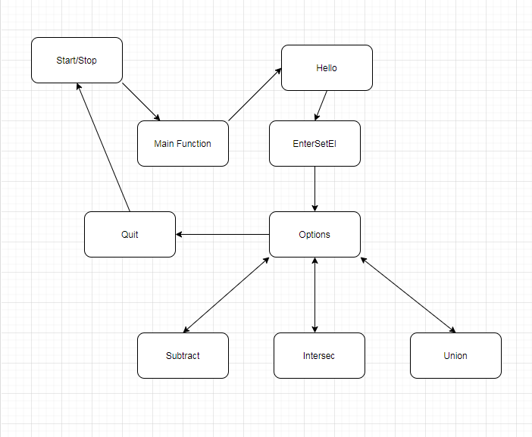
  1. **Realization**

To realize the project we had to collaborate, work hard on the program, make a long talks on teams, commit a lot of things in Github so we can finally combine and make a whole working program. Every one of us had done their part of the project so that is how everything is done. Teamworking is the best path of the programming!

* 1. **Description of the projects**

The project we have made is connected with mathematical actions with sets of numbers. Our program is very useful if you want to take actions with sets of numbers. It is very easy to use and it can be used by everyone, it has a very good menu where you can see all the options we had given you.

* 1. **Conclusion**

While making the project we had a lot of fun and also a lot of hard parts making the program especially. We made a new friendships and worked hard together to make a good and working program. We went through hard moments because when we thought we can’t do nothing there came our scrum trainer and motivated us to make the project as good as it is now.